How Much to Pack*

Mr. Akash, Manager of the Packing division of CEREALKING, looked at the internal audit committee’s report, that is lying on his desk. Mrs. Katti, his boss, must have left it there last night before leaving. Some part of the report is highlighted; it says that the company suffered a loss of nearly one crore in the last three years because of over-packing its pouches. No sooner had Akash settled down for the day, he got summoned to the Boss’s office; he could guess what it was about.

‘These folks do not understand that we cannot afford to under-pack, we could be caught by FDA (Food and Drag administration) or worse, if our customers come to know of it, that would be the end of our business’, Akash murmured, as he entered Mrs. Katti’s room. ‘I agree,’ Akash heard and his face brightened for a moment. But his relief did not last long as Mrs. Katti continued: ‘but, do we really need to over-pack as much as YOU do? Surely, FDA would give a bit of lee-away and the consumers would not mind if the content is few grams lower once in a while. Go, and first check the FDA guidelines once more.’

CEREALKING is one of leaders of breakfast cereals market in the country and most of its products are sold in one-kilogram packets; apparently the problem is most for pouches of that size only. Mr. Akash took the initiative two years ago in going for an advanced filling machine that can be used for filling the packets with cereals for any set weight. Of course, when the machine is set at one kilogram, there is some variation in the amount actually filled. That is precisely why, Akash needed to set the machine at one kilogram plus 5 gram level. Akash took pride in his work and he believed that the excess amount set is the minimum required to ensure that pouches will almost never be under-filled. But, now that it is creating so much of a problem, may be he ought to rethink about his setting.

Somewhat grudgingly Akash opened the FDA guidelines. Sure enough, Mrs. Katti is right (as usual). The relevant portion of the guidelines reads:

i) No more than 1% of the packets/products can be below the weight/amount specified by the label. **= Means if company produces 10000 packets no more than 100 packets should be underweight.**

ii) Among the under-weighed packets, the average deficiency can be no higher than 0.5% of the amount specified by the label. **= If the packets are 1000gm no more than 5gm underweight**

Mr. Akash returned to Mrs. Katti with the FDA guidelines and asked for some tips. That brought a smile in Mrs. Katti face: ‘Akash, it is high time, we get something concrete out of the management training we had sent you’, making obvious reference to the thirteen week exercise Akash had undergone at the International Institute of Management Billekhahali (IIMB) in the last year. ‘I remember you were abnormally excited about some normal distribution after returning from the training. Can you apply it here?’ ‘Yes Madam, I collected a lot of data and I was very happy to note the difference

* Shubhabrata Das, Indian Institute of Management Bangalore

between the actual weight and the specification set of machine followed almost exactly a NORMAL distribution. But I was not sure of its implication back then.’ ‘I hope you know the implication NOW. I think, FDA guidelines are loose enough, you are simply not taking full advantage of it,’ Mrs. Katti said, making it clear that Akash should not waste any more of her time on this.

Akash started wondering. The machine is a good one; so the average of deviations from specification is essentially zero. But he needed the standard deviation value (of the deviation from specification) badly. His computer had crashed couple of months ago and he had lost all the data in the crash. Even an approximate value would do to start with. In the worse case, he would need to collect fresh data. Are both the guidelines equally important or useful to him? The final and the most important question, of course, is, at what level should he set the machine for filling the one-kilogram packets?

We have issues with this:

We don’t have the std. dev. values. So we can assume that min is 1000gm and max is 1010gm. So 1010gm – 1000gm = 6*std. dev.

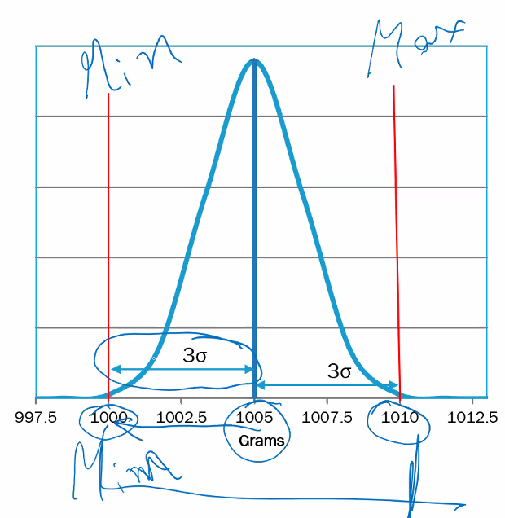

Solution:

The problem states that there is an issue of packages being over packed. There are facts that are being reflected as below:

1. The weights of the packets are stated as 1000gm.
2. The machine mean is set at 1005gm
3. Sample study proved that the machines didn’t produce any packets < 1000gm. So we can safely say that the lower bound of our data which follows a normal distribution is 1000gm. Thus by symmetry the upper bound should be 1010gm. This assumption gives rise to the below two metrics for our normal distribution model:
   1. µ = 1005gm
   2. σ = (1010 – 1000)/6. By properties of normal distribution we know that almost all of the data lies between ±3σ away from mean.

Thus we can model the current distribution as below:

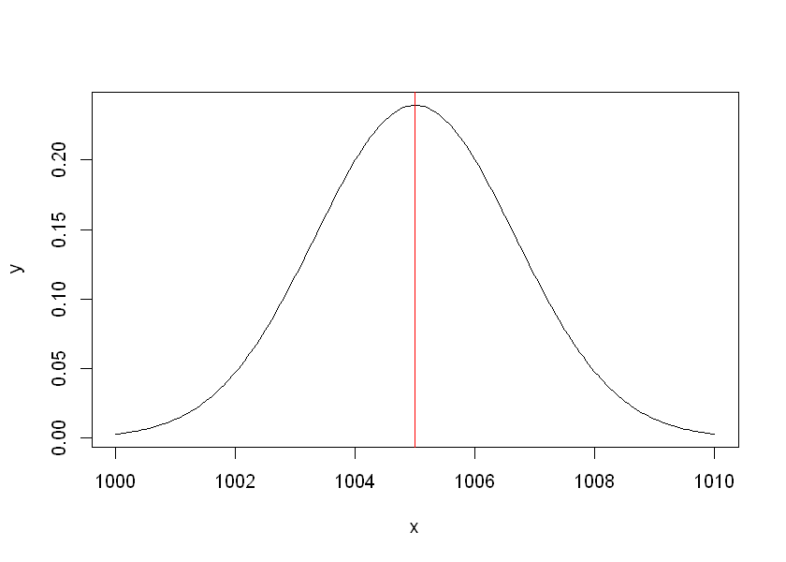

Now as per FDA’s guideline: No more than 1% of the packets/products can be below the weight/amount specified by the label it mentions that the allowed probability of packets being underweight <= 1%. So we have to find a new distribution whose mean should be set such a way that it doesn’t violate FDA regulation.

To do this find the Z value such that the probability of the normal distribution is 1%.

Thus the required Z value should be = -2.32634787404084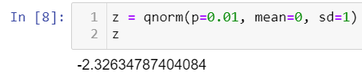

Now we map this Z value to our use case to find the new mean.

In other words, 1000gm should be -2.326σ away from mean.

* (µ - 1000)/σ = 2.326
* (µ - 1000)/1.667 = 2.326
* µ - 1000 = 2.326*1.667 = 3.876
* µ = 1003.876gm

Thus if we set the µ at 1003.88gm we will achieve a distribution such that which will not be violating the FDA guidelines and will be < 1%.

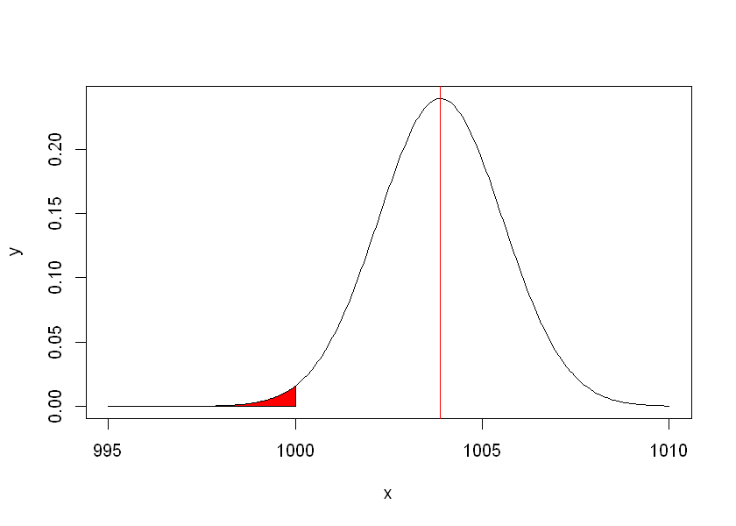

Check our calculations:

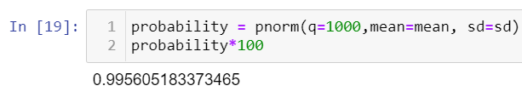

Now the new µ = 1003.88gm σ = 1.667gm.

Stated label of weight = 1000gm in label.

Allowable underweight limit = -5gm i.e. 995gm

So in our new distribution let us find the Probability value that a packet from the sample space <= 995gm.

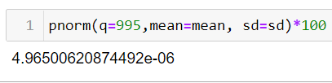

Thus we can surely say that setting this mean as 1003.88gm and std. dev. as 1.667gm probability of a packet violating FDA guideline by being underweight is 4.965e-06%. In other words if the company produces 1000000 (1 Million) packets approximately 5 packets can be found out of them to be underweight.